The Jr./Sr. Youth Drop-In has moved to Thursday's.
We gather at 3:00pm and conclude around 6:00pm.
We can always use help teaching the youth a life skill,
cooking and serving dinner with the youth, or
just hanging out and being present for them.
Talk to Lauri or Will if you can assist in any way!

Did you know that you can worship at Sprakers on the first and third Sunday's at 9:00am and
join them for Second Saturday at 6:00pm or the Gathering on the fourth Saturday at 6:00pm (meal included in the Saturday get togethers)??

Faith Formation Team is scheduled to meet
at 10:00am on January 19th in Fellowship Hall.
Anyone can be part of this team, so please feel free to
join us.

Fort Plain Consistory will meet on January 26th at 6:00pm
in Fellowship Hall

Thank you Lauri Broady for leading worship today!

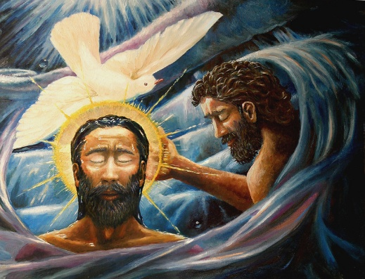
Fort Plain Reformed Church
January 11, 2026

ANNOUNCEMENTS/PRAYER

PRELUDE We Greet Thee, Heavenly Dove Rinehart

*CALL TO WORSHIP
God of grace and glory,
you call us with your voice of flame
to be your people, faithful and courageous.
As your beloved Son
embraced his mission in the waters of baptism,
inspire us with the fire of your Spirit
to join in his transforming work.
We ask this in the name of our Savior Jesus Christ,
who lives and reigns for ever and ever. Amen.

*HYMN “Baptized in Water” (WC 758)

PRAYER OF CONFESSION (Unison)
Gracious God,
Our sins are too heavy to carry,
too real to hide,
too deep to undo.
Forgive: what our lips tremble to name,
what our hearts can no longer bear,
and what has become a consuming fire of judgement.
Set us free from a past we can’t change,
open us to a future in which we CAN be changed,
and grant us grace to grow more and more in your image,
through Jesus Christ, the light of the world. Amen.

DECLARATION OF FORGIVENESS
* ~Gloria Patri~
PRAYER OF ILLUMINATION

SCRIPTURE
Acts 10: 34-43 Psalm 27:1-5 Matthew 3:13-17

SERMON “We All Belong”

*HYMN “We Bless the Name of Christ the Lord” (WC 761)
SHARING OF OUR TITHES AND GIFTS
Special Music When Jesus Came to Jordan Green

PROFESSION OF FAITH
Please respond to each question with “I do”

PRAYERS OF THE PEOPLE

BLESSING

*HYMN “Christ for the World! We Sing” (WC 743)

POSTLUDE Glory To God Paxton

