SHARING OF OUR TITHES AND GIFTS
OFFERTORY A Communion Hymn For Christmas Clarkson/Fettke
*Doxology/Prayer

COMMUNION

*BLESSING

*HYMN "The First Noel" (WC #162)

*POSTLUDE Glory to the Newborn King Frank Ritter

Webpage: fortplainandsprakersreformed.org
(Did you know you can find each week’s service on our website?)

Pastor Ryan will be on vacation January 5-14
If you have an emergency, please contact
Michele Whiteman, Consistory Vice President
518-421-2969

Your help with the Drop In Ministry is appreciated,
for the winter months we meet on Thursday afternoons
see Lauri Broady if you would like to help in ANY way!

Consistory will meet at 6:00pm on January 26th

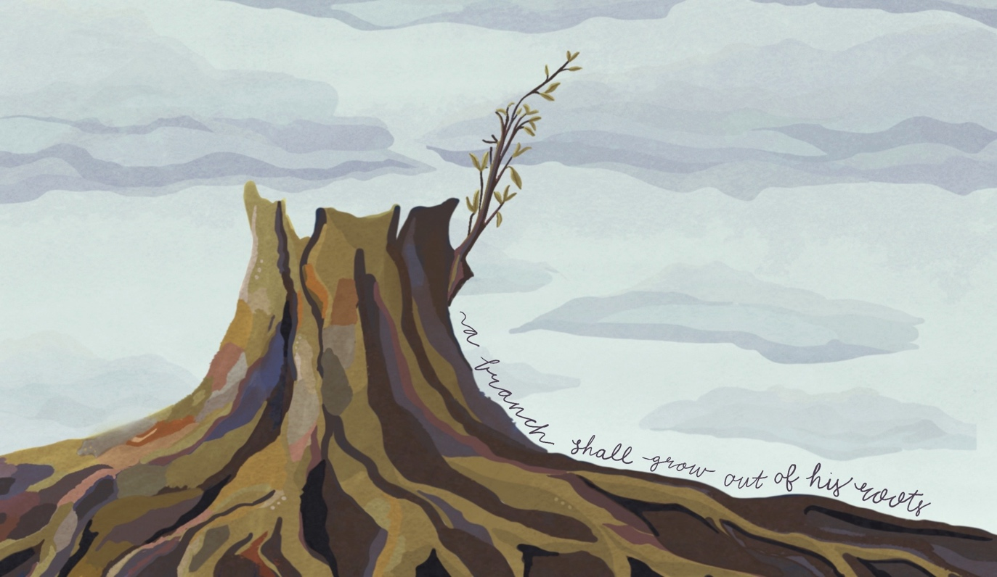
Epiphany January 4, 2025

PRELUDE The Newborn King Gilbert Martin

*CALL TO WORSHIP-
Hear this prophecy from Isaiah 60:
Arise, shine, for your light has come,
and the glory of the Lord has risen upon you.
For darkness shall cover the earth
and thick darkness the peoples,
but the Lord will arise upon you,
and his glory will appear over you.
Nations shall come to your light
and kings to the brightness of your dawn.
[Light the Christ candle.]
Lift up your eyes and look around;
they all gather together; they come to you;
your sons shall come from far away,
and your daughters shall be carried in their nurses’ arms.
Then you shall see and be radiant;
your heart shall thrill and rejoice,
because the abundance of the sea shall be brought to you;
the wealth of the nations shall come to you.
A multitude of camels shall cover you,
the young camels of Midian and Ephah;
all those from Sheba shall come.
They shall bring gold and frankincense
and shall proclaim the praise of the Lord.
*HYMN "Arise, Shine, for Your Light has Come" INSERT
PRAYER OF CONFESSION
Jesus Christ, light of the world,
come dwell in us so that we may dwell in you.
Shine your light in the dark places of our lives,
so that we may see the evil of our ways,
the dark thoughts we harbor,
the secrets we keep,
and in seeing them, we might turn to you for help.
Forgive us, for the sin that resides within us,
and for the things we have done that we shouldn’t have.
Cleanse us. Purify us. Heal us.
Sung Refrain
Jesus Christ, light of the world,
come dwell in us so that we may dwell in you.
Forgive us for whatever parts we play
actively or through our inaction and silence.
Cleanse us. Purify us. Heal us. silent confession

DECLARATION OF FORGIVENESS

SCRIPTURE Matthew 2:1–12 Romans 11:17–24

SERMON

*HYMN "We Three Kings of Orient Are" (WC #185)

*PROFESSION OF FAITH
People of God, what do you declare today?
We believe
that God has entrusted the church
with the message of reconciliation
in and through Jesus Christ.
We believe
that the church is called to be the salt of the earth
and the light of the world.
We believe,
that the church is called blessed
because it is a peacemaker.
We believe,
that the church is witness
both by word and by deed
to the new heaven and the new earth
in which righteousness dwells.

