SHARING OF OUR TITHES AND GIFTS
OFFERTORY "Prepare the Way" Darrell Rvans and Eric Nuzum
*Doxology/Prayer

COMMUNION

*BLESSING

*HYMN "O Come, O Come, Emmanuel" (vss. 1, 3, 4 WC# 133)

*POSTLUDE Wexford Carol James Mansfield

Webpage: fortplainandsprakersreformed.org
(Did you know you can find each week’s service on our website?)

Consistory will meet at Bev Dingman's home
December 9 @ 5:30 pm

Holiday Basket Raffle
buy tickets after worship today!
Raffle will be held on Saturday, December 13 @ 11:30 am
cookies and punch will be served!

Food Pantry will be open December 17th from 10-Noon
We are open 24/7 for emergency food needs
315-360-2345

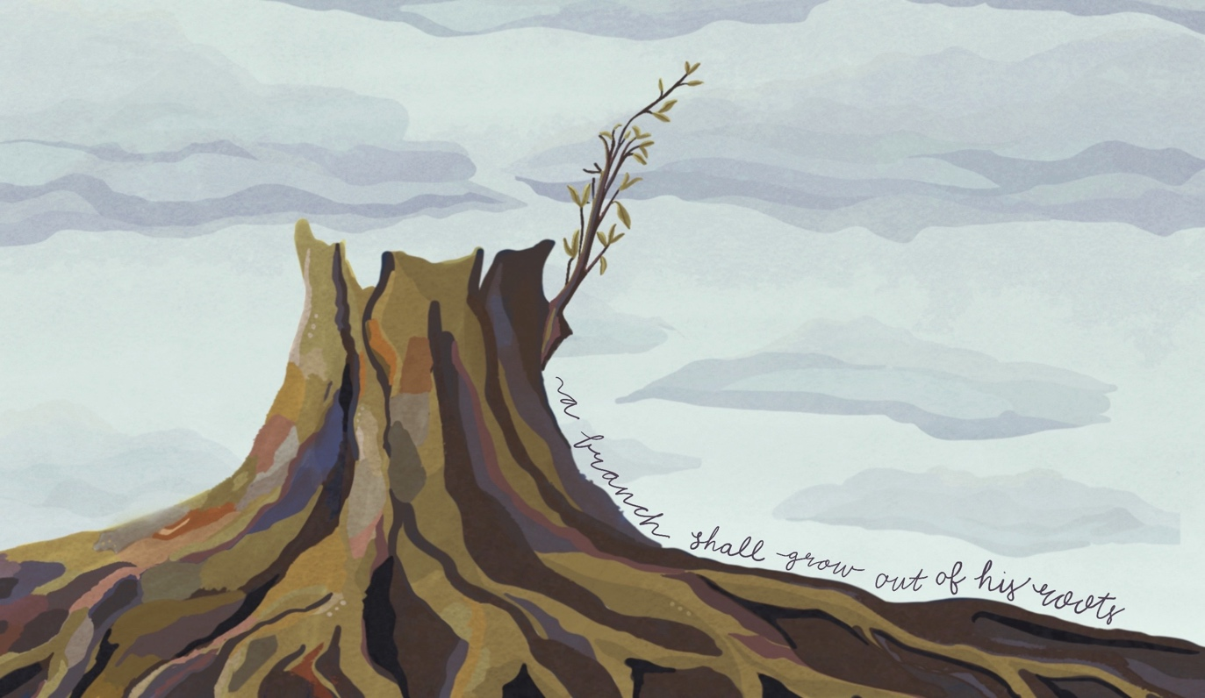
ADVENT II 2025

PRELUDE "Lord, Make Me An Instrument of Peace"

INTROIT
followed by silence...

CALL TO WORSHIP- and ADVENT CANDLE
Light One Candle To Wait for Messiah (vss. 1-2, insert)
Out of darkness a light shines.
Out of silence a voice cries, “prepare the way of the Lord.”
From a dead stump shoots grow.
Out of chaos a people flourish;
righteousness and peace kiss.
Today we continue the Advent journey.
Today we light this candle of peace.
[second candle is lit]
God invites us,
“let them make peace with me, let them make peace with me.”
Love and faithfulness meet together;
righteousness and peace kiss each other.
Faithfulness springs forth from the earth,
and righteousness looks down from heaven.
The LORD will indeed give what is good,
and our land will yield its harvest.
Righteousness goes before him
and prepares the way for his steps.

*HYMN "Comfort, Comfort Now My People (WC # 132)

SCRIPTURE Isaiah 27:1-6 Psalm 85 Matthew 3:1-12

SERMON

*HYMN "Lord, Make Me An Instrument of Peace" (Insert)

PRAYER OF CONFESSION
God of mercy hear our prayer, bring peace to earth again
“Restore us again, God our Savior,
and put away your displeasure toward us.
Will you be angry with us forever?
Will you prolong your anger through all generations?
Will you not revive us again,
that your people may rejoice in you?
Show us your unfailing love, LORD,
and grant us your salvation.”
(Psalm 85:4–7, NIV)
God of mercy hear our prayer, bring peace to earth again
Lord, forgive us.
Save your people.
Nourish us with your grace so that we may “take root,
blossom, put forth shoots, and fill the whole world with fruit” Amen.
(Isaiah 27:6, adapt.)
God of mercy hear our prayer, bring peace to earth again
-silence-

DECLARATION OF FORGIVENESS
Receive these words of grace from Psalm 85:

You, LORD, showed favor to your land;
you restored the fortunes of Jacob.
You forgave the iniquity of your people
and covered all their sins.
You set aside all your wrath
and turned from your fierce anger.
The LORD will indeed give what is good,
and our land will yield its harvest.
*Emmanuel, Emmanuel (WC # 140)

*PROFESSION OF FAITH Our Song of Hope, stz. 11
We pray for the fruits of the Spirit of Christ
who works for peace on earth,
commands us to love our enemies,
and calls for patience among the nations.
We give thanks for God’s work among governments,
seeking to resolve disputes by means other than war,
placing human kindness above national pride,
replacing the curse of war with international self-control.

